## Individual Assignment 5: MongoDB

1. All the companies whose name starts with 'Babe'. Retrieve only their name field.

db.Companies.find({"name": /^Babe/},{name:1, _id:0})

2. All the companies that have greater than or equal to 5000 employees. Limit the search to 20   
companies and sort them by number of employees in ascending order. Only display company   
names and numbers of employees.

db.Companies.find({number_of_employees:{$gte:5000}}, {name:1, number_of_employees:1, _id:0}).limit(20).sort({number_of_employees:1})

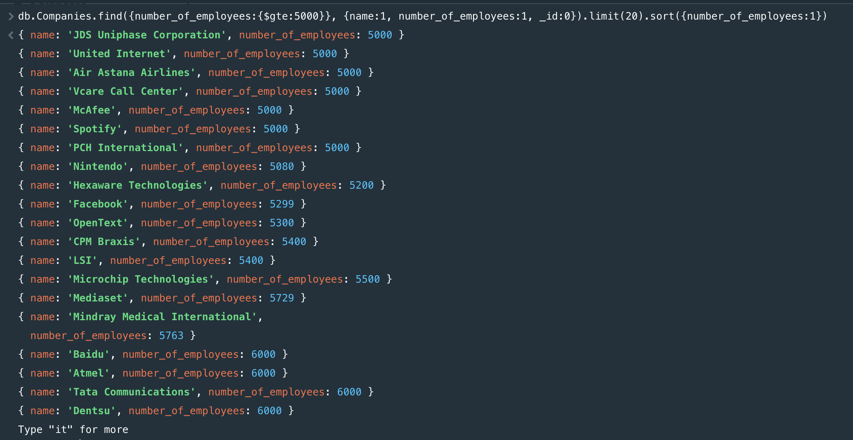

3. All the companies that had a Valuation Amount (ipo.valuation_amount) of more than   
100,000,000 and have been founded before 2010. Retrieve only the name and ipo fields.

db.Companies.find({$and:[{"ipo.valuation_amount": {$gt: 100000000}}, {founded_year: {$lt: 2010}}]}, {name:1, ipo: 1, _id:0})

4. All the companies that have one and only one partners. Only show the name and partners   
fields.

db.Companies.find({partners: {$size:1}}, {name:1, partners:1, _id:0})

5. All the companies that 1) have at least 100 employees and founded before 2010, or 2) have   
at least 1000 employees and founded before 2005. Display the fields name,   
number_of_employees, and founded_year.

db.Companies.find({$or: [{$and: [{number_of_employees: {$gte:100}}, {founded_year: {$lt:2010}}]},{$and: [{number_of_employees: {$gte:1000}}, {founded_year: {$lt:2005}}]}]}, {name:1, number_of_employees:1, founded_year:1, _id:0})

6. All the companies that have been founded on the first seven days of the month, including the   
seventh. Sort them by their acquisition price in descending order. Display company names and   
acquisition prices. Limit the search to 10 documents.

db.Companies.find({founded_day: {$lte: 7}}, {name:1, "acquisition.price_amount":1, _id:0}).sort({"acquisition.price_amount":-1}).limit(10)

7. All the companies that have at least one office located in Cambridge, the United States of   
America. Display company names and offices.

db.Companies.find({$and: [{"offices.city": {$regex: "Cambridge"}}, {"offices.country_code": {$regex: "USA"}}]}, {name:1, offices:1, _id:0})

8. All the companies on the 'web' category that have more than 4000 employees. Display   
company names, categories, and numbers of employees. Sort them by the amount of   
employees in ascending order.

db.Companies.find({$and: [{category_code: {$regex: "web"}}, {number_of_employees: {$gt: 4000}}]}, {name:1, category_code:1, number_of_employees:1, _id:0}).sort({number_of_employees:1})

9. All the companies whose acquisition amount is more than 10,000,000, and currency is 'EUR'.   
Use the "acquisitions" field to answer this question. Note that there might be multiple   
acquisitions. Include the company if at least one of the acquisitions meets the above-  
mentioned conditions. Only display their name and acquisitions fields.

db.Companies.find({$and: [{"acquisitions.price_amount": {$gt: 10000000}}, {"acquisitions.price_currency_code": {$regex: "EUR"}}]}, {name:1, acquisitions:1,_id:0})

10. All the companies that have been founded between 2000 and 2010, but have not been   
acquired till now (size of the acquisitions field is 0). Display the company names founded years.

db.Companies.find({$and: [{founded_year: {$in: [2000,2001,2002,2003,2004,2005,2006,2007,2008,2009,2010]}}, {acquisitions: {$size: 0}}]}, {name:1, founded_year:1, _id:0})

